***CIS623 Project 2***

**Adaptable User Interfaces Submitted By Lohith Nimmala**

Entire UI is available at : https://gvsuschedulemanager.herokuapp.com

Entire Code for this is available at : <https://github.com/Lohith499/CIS623-Proj2>

Login as Fresher or Sophomore : User ID : Student1 Password :1234

Login as Senior : User ID: Student2 Password: 1234

Login as Admin or Teacher : User ID : Teacher Password : 1234

When user logins in as Fresher or Sophomore user will be directed to Search by Category

When user logins in as Senior user will be directed to Search by Discipline

When user logins in as Admin or Teacher user will be directed to Advance Search

Every page is designed for Mobile layout Compatibility

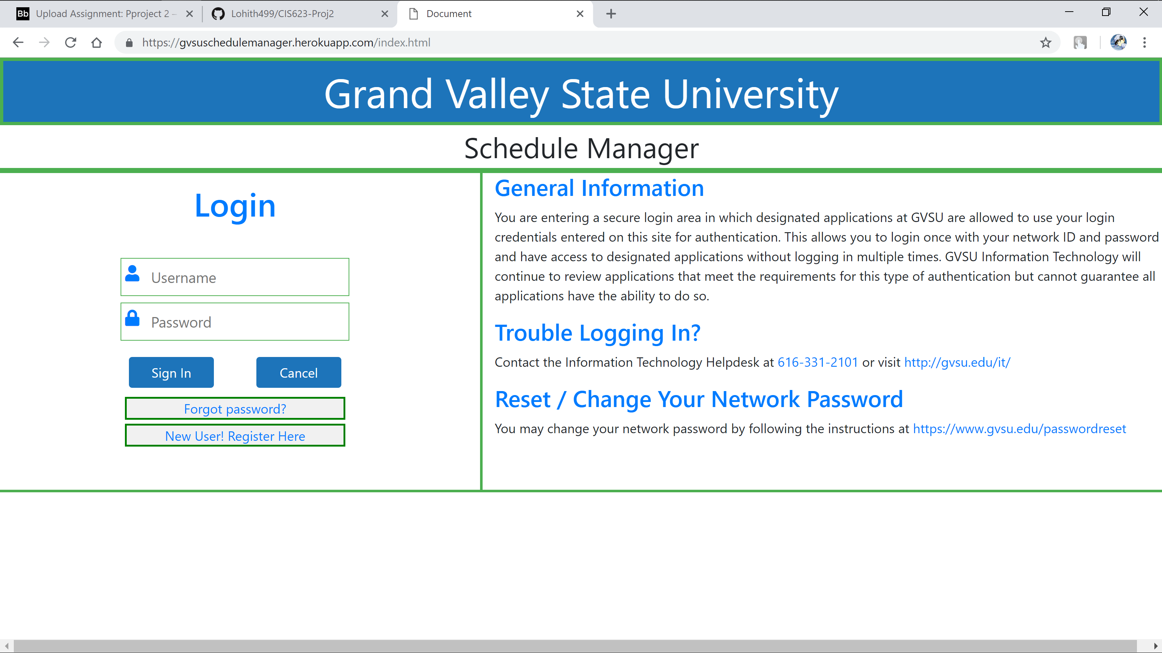

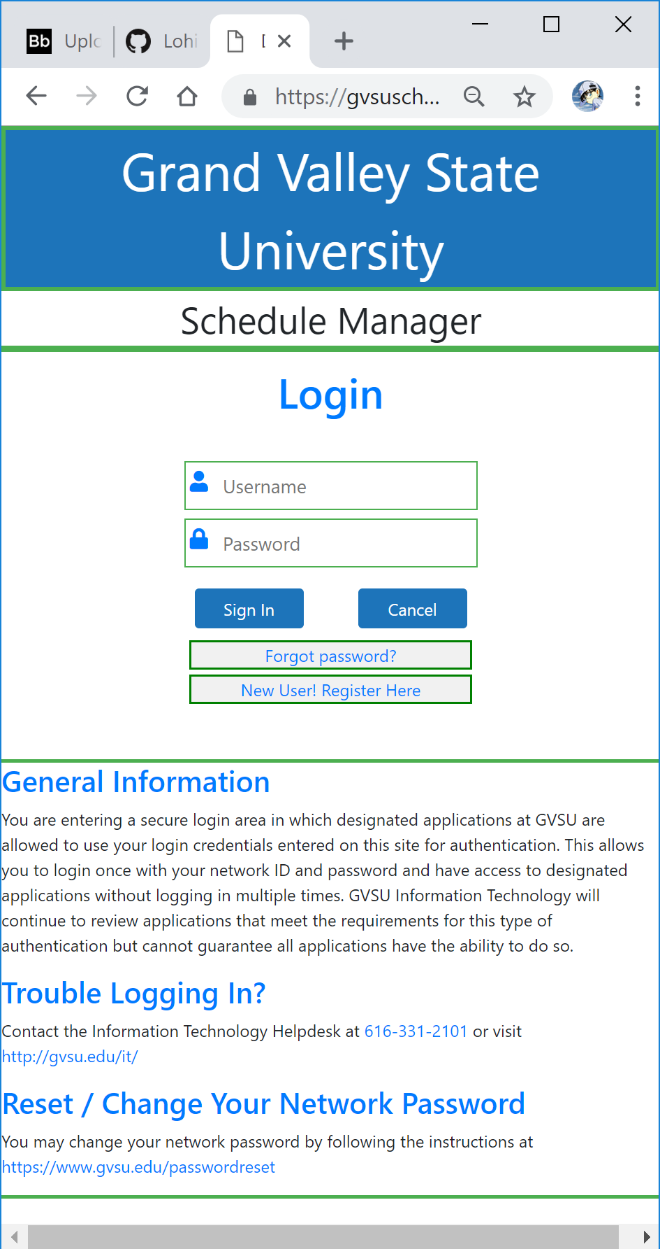

After login as Senior

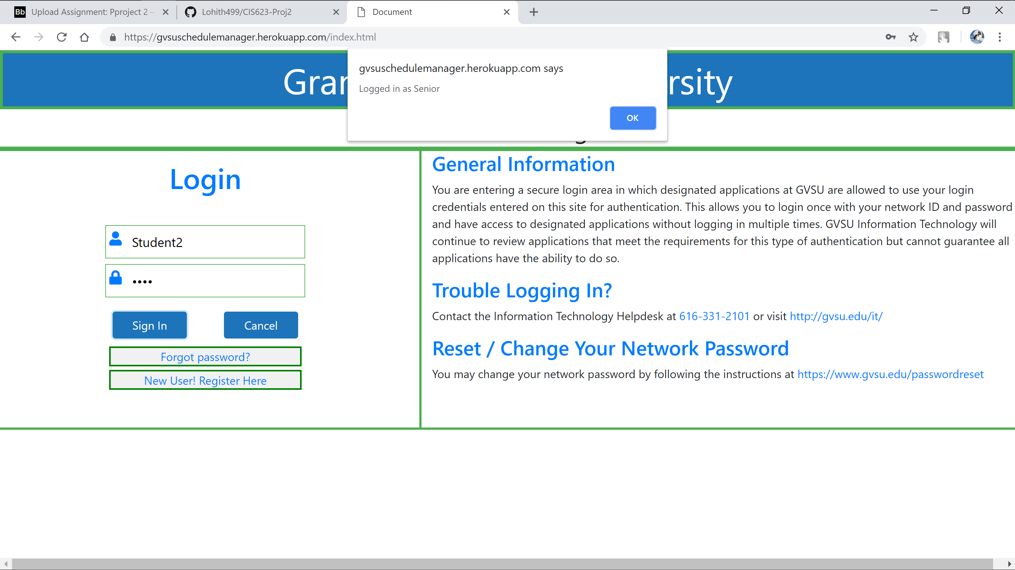

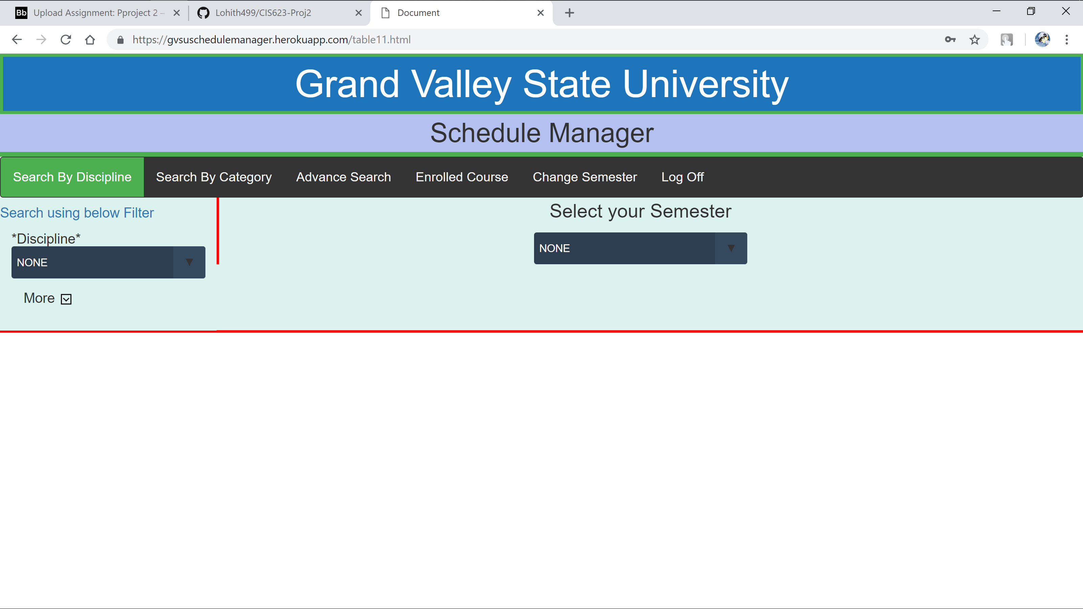

User has to select Semester first to search for any course

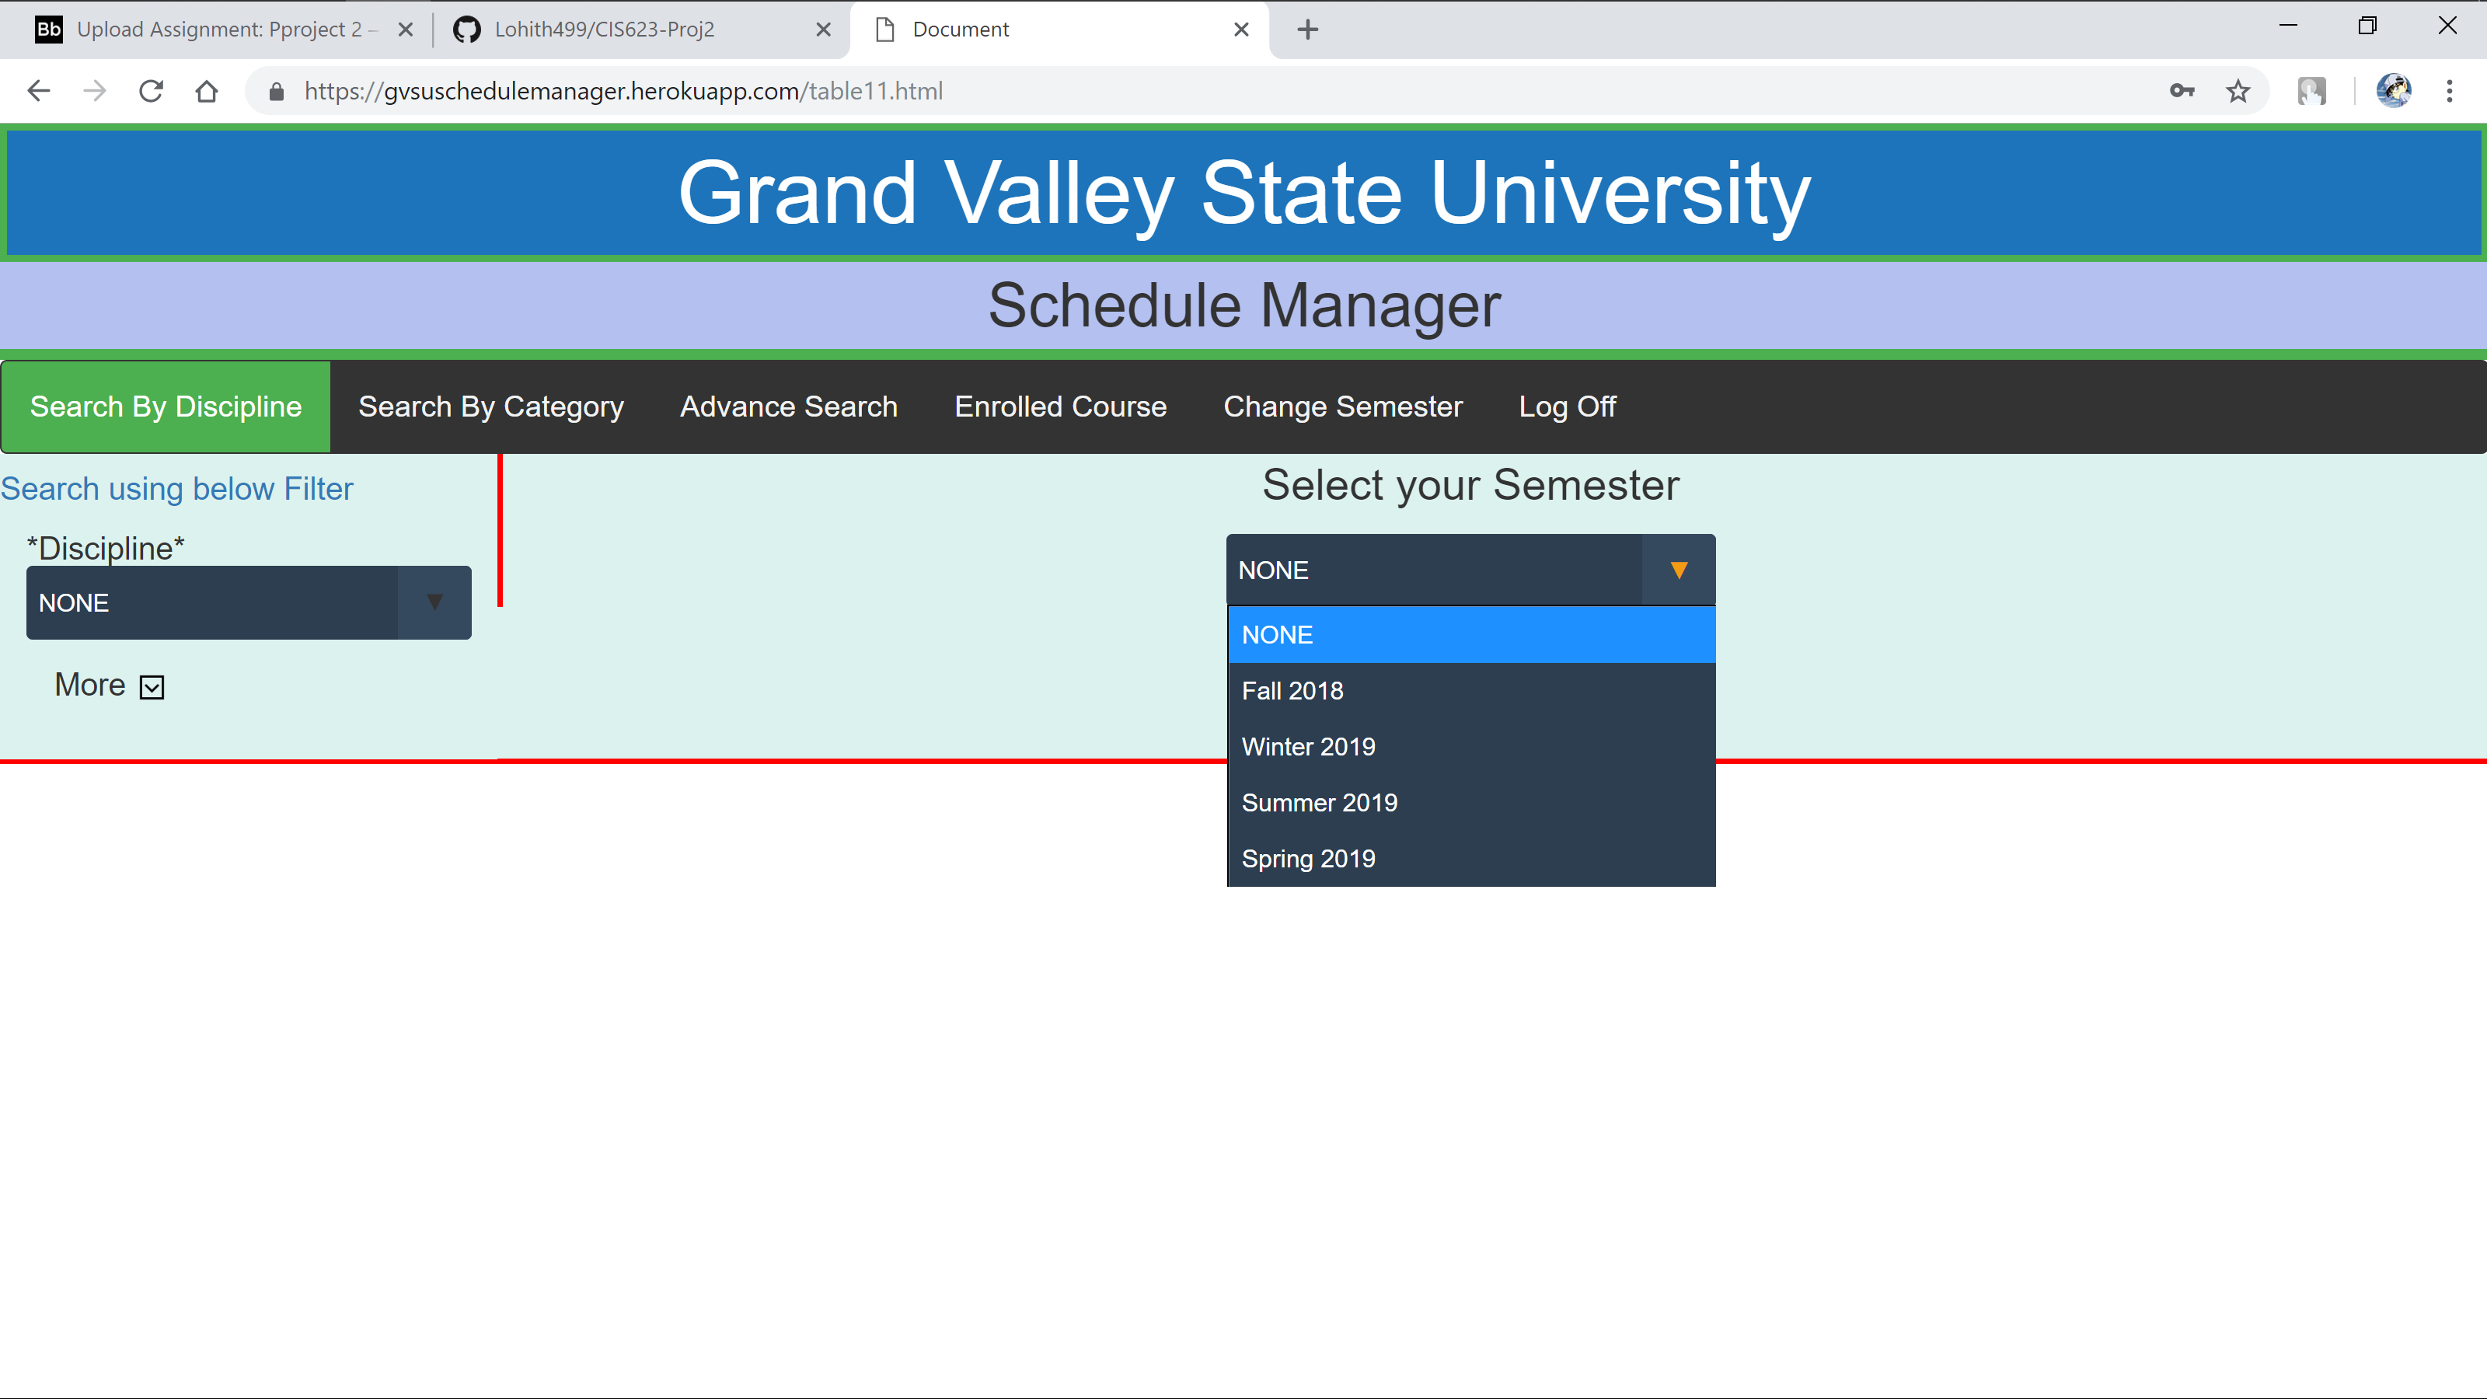

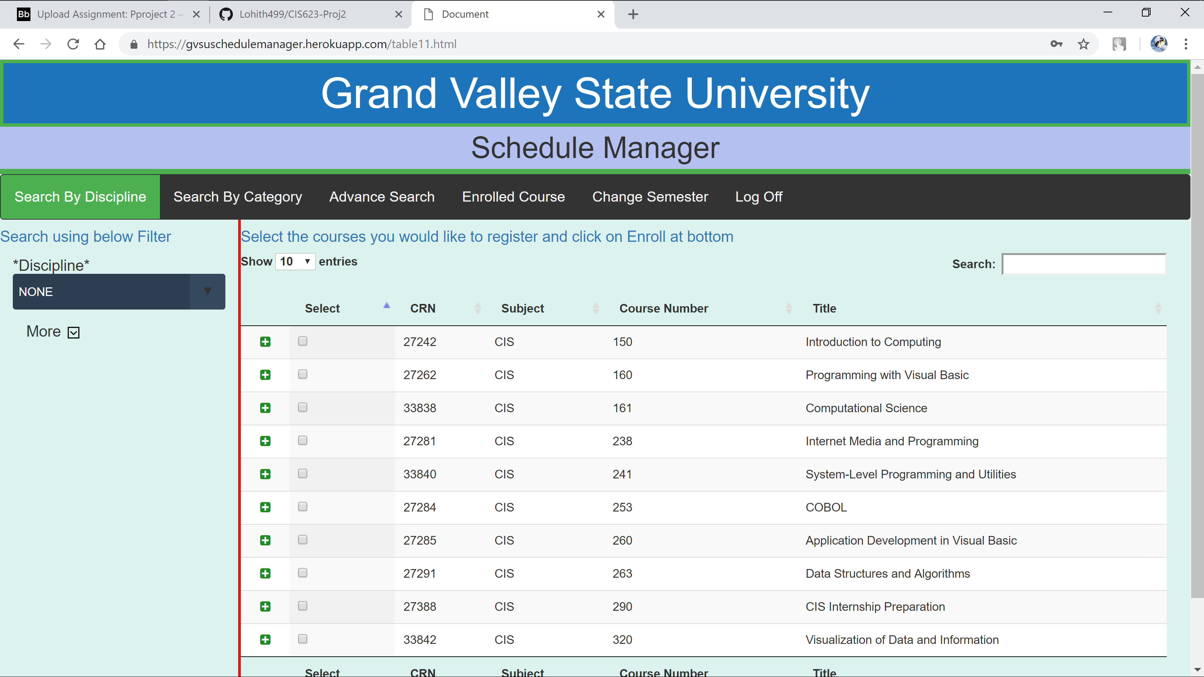

As soon as Semester is selected will populate all courses for quick search.

But if user wants to search using Discipline they can filter the results by selecting the Discipline value

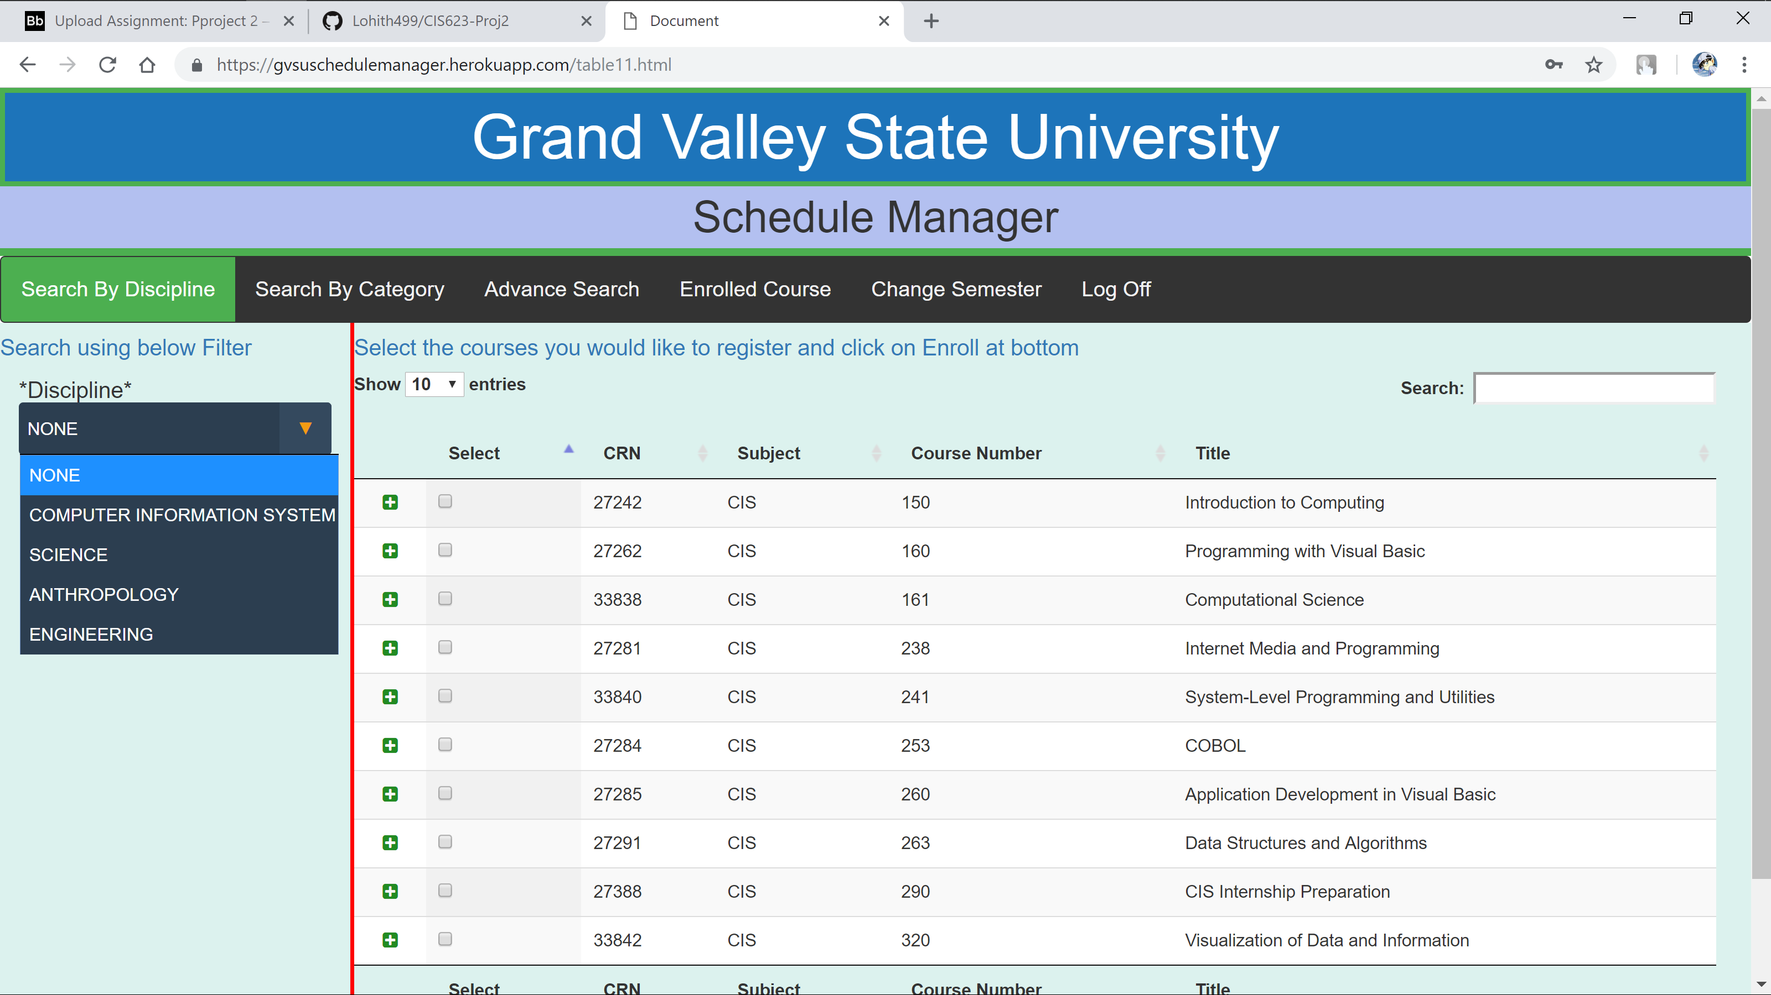



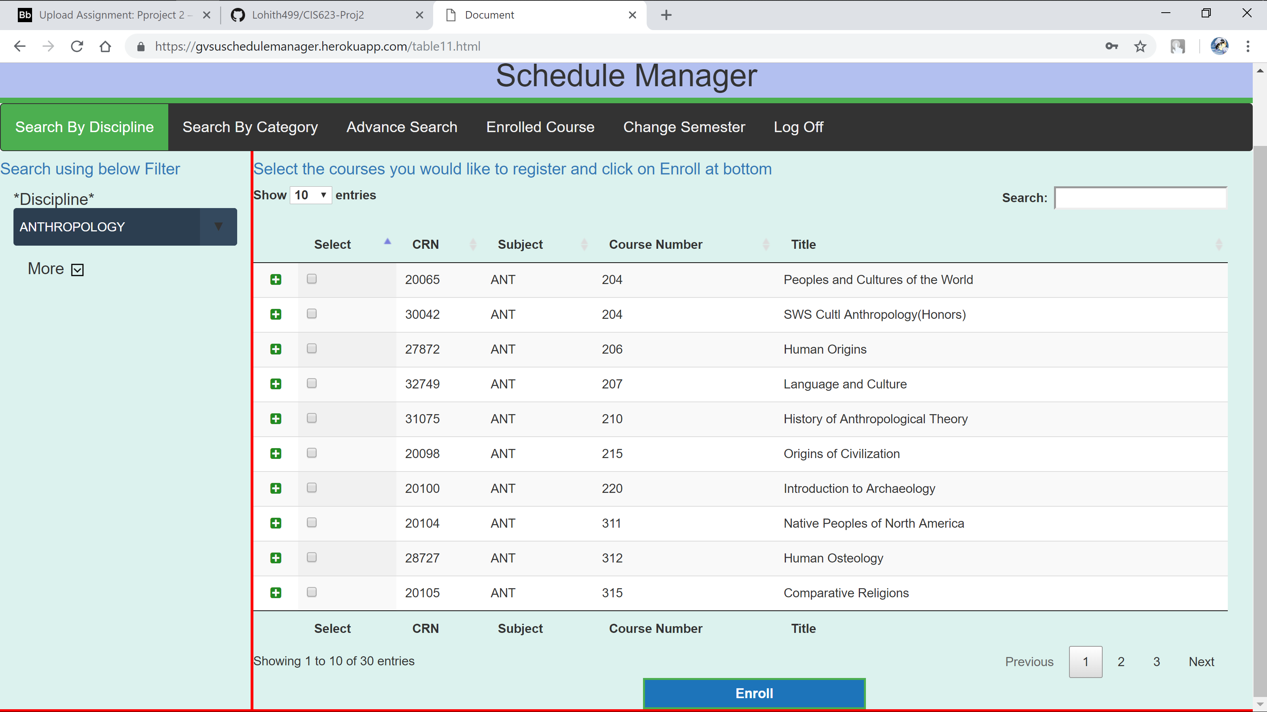

If user wants more filtering they just need to click more

That will display search by Category dropdown and also highlight the Search By Category tab

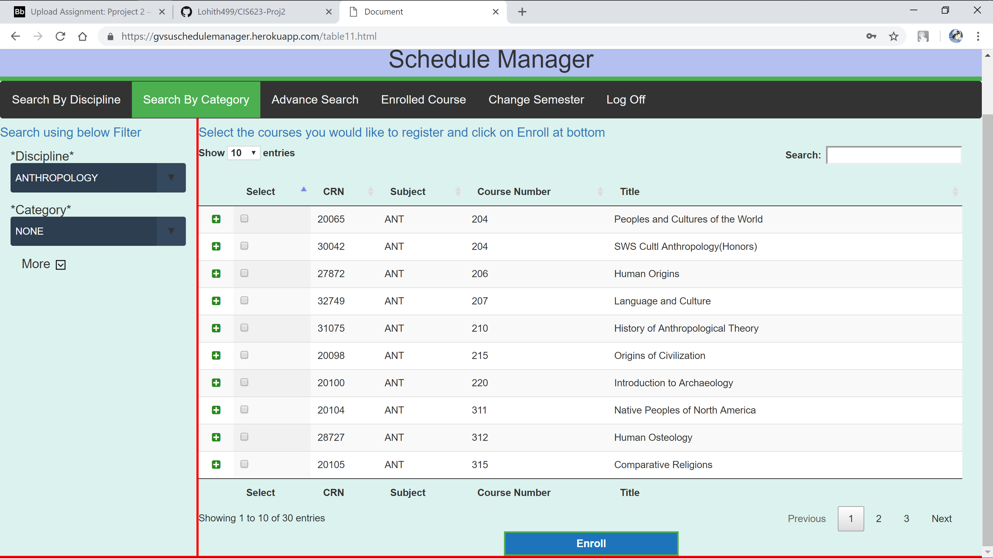

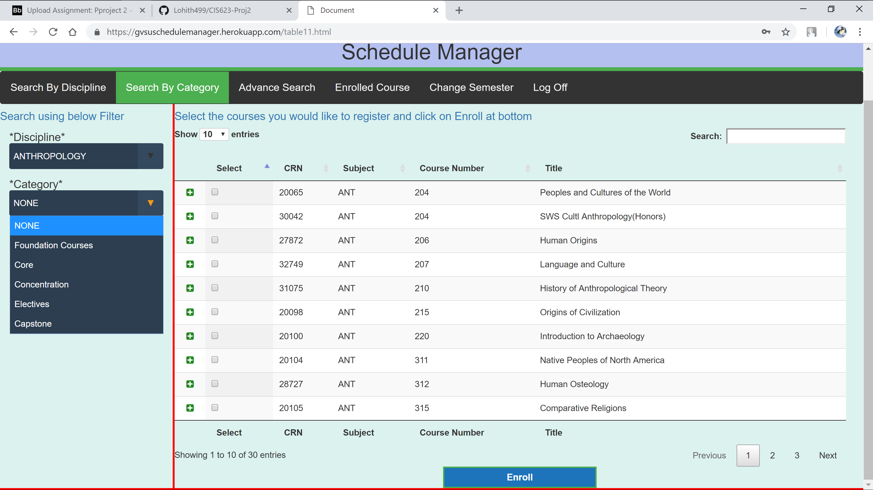

The results will filter based o the Category

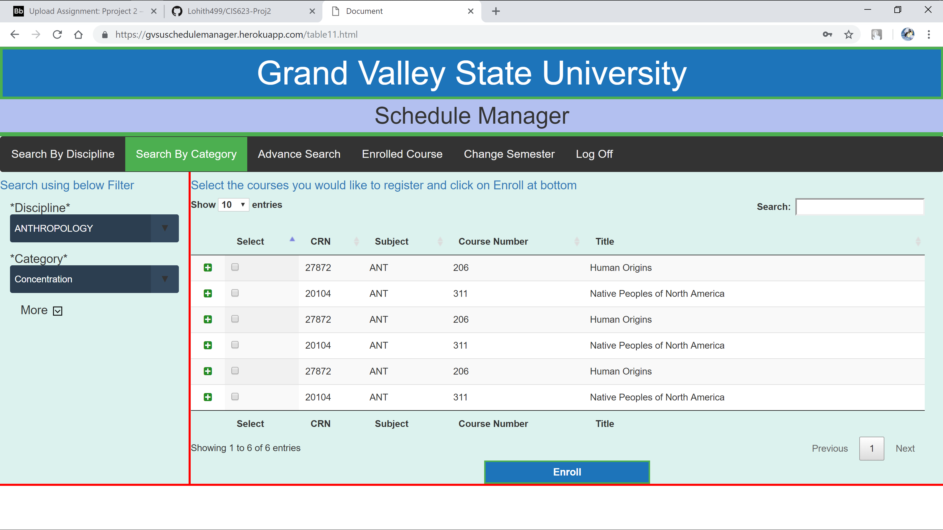

If they want more filtering they can do it by clicking on More link and it will route the User to Advance Search

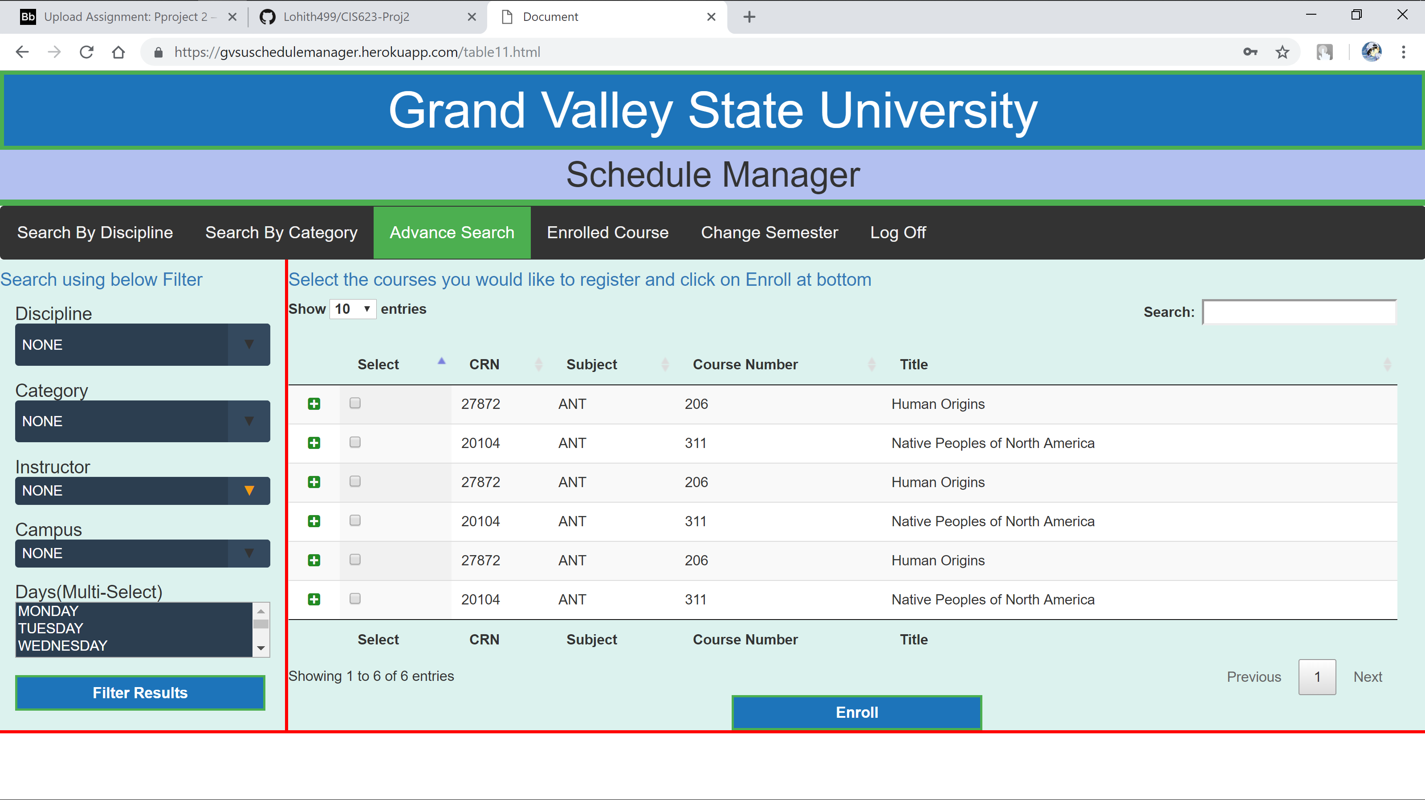

Where user can select multiple fields and click on Filter Results button to more advance filtering

In order to view more about course user don’t need to navigate to new page, they just need to click on **“+”**  symbol in each row , this way they can even see two course details at a time for more choosing analysis

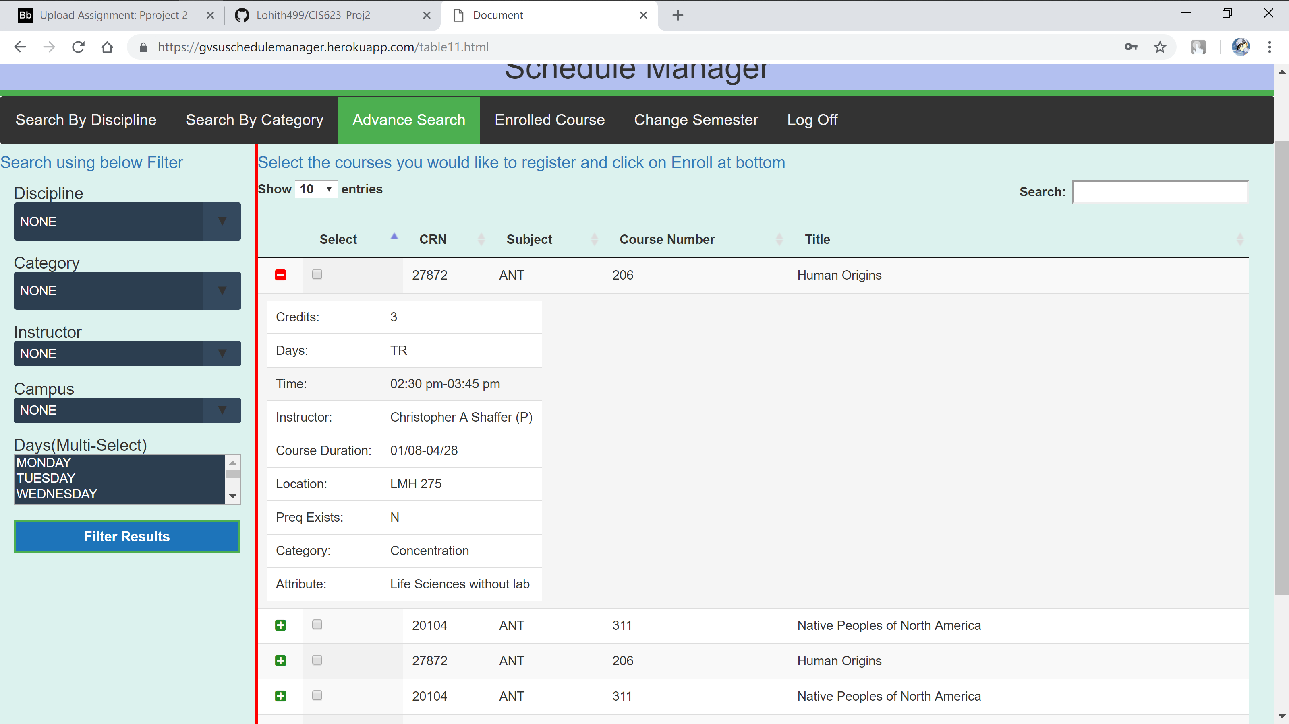

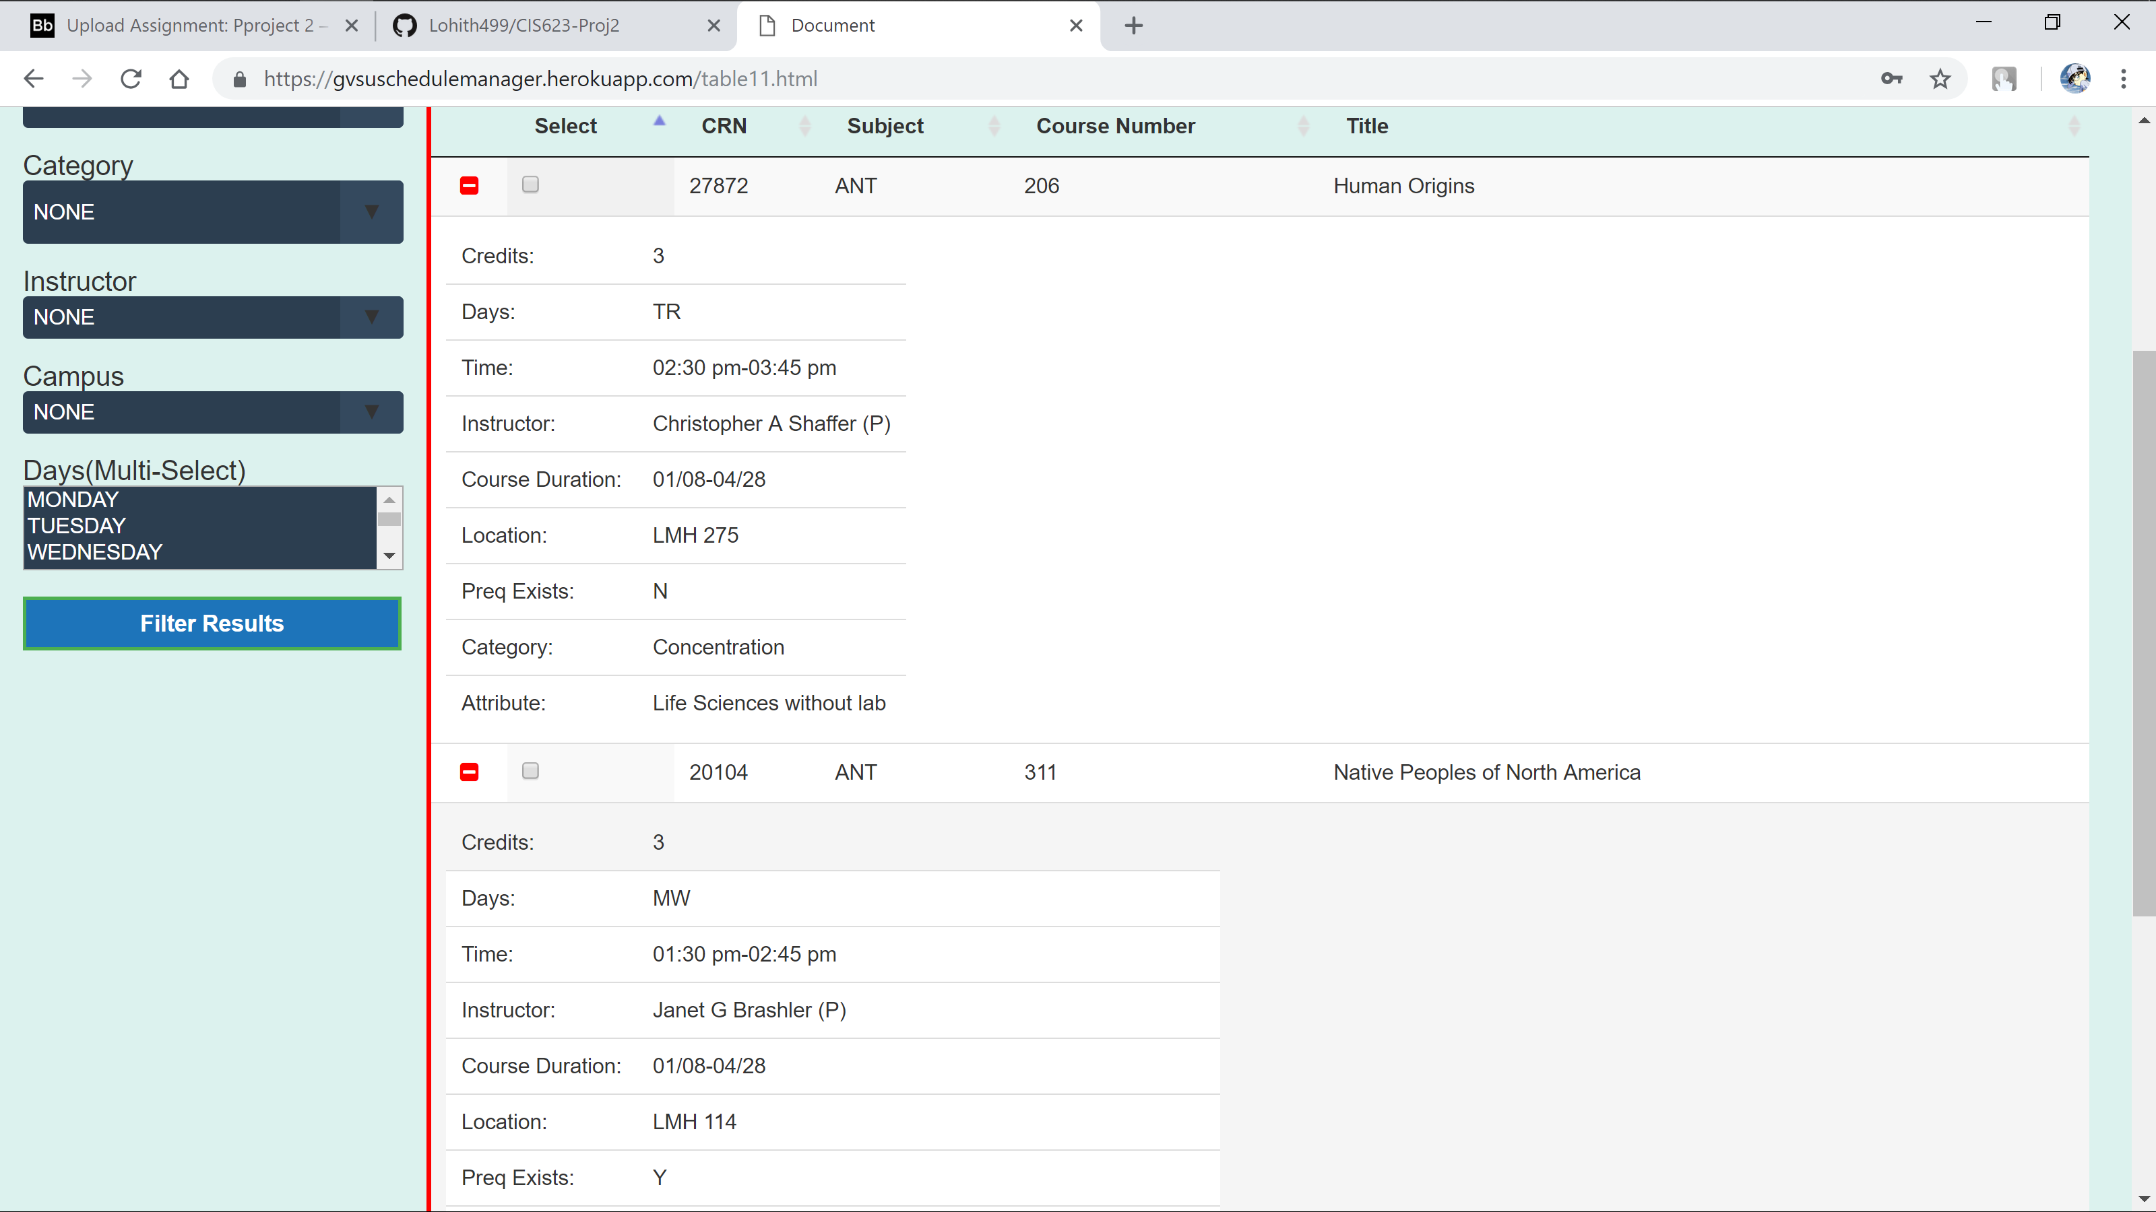

User can filter from results using search texdt box at top of the table using word search , which will filter results based on matching word in any of the columns

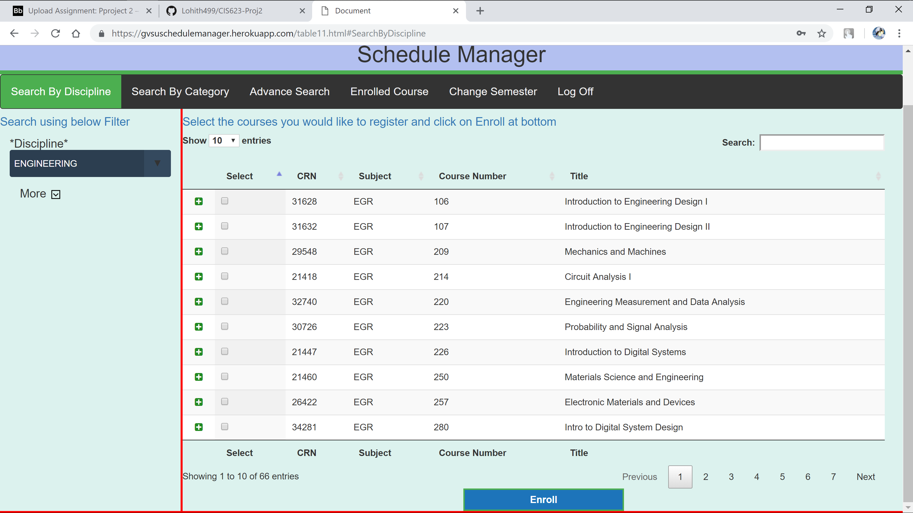

Courses with word Design will be displayed



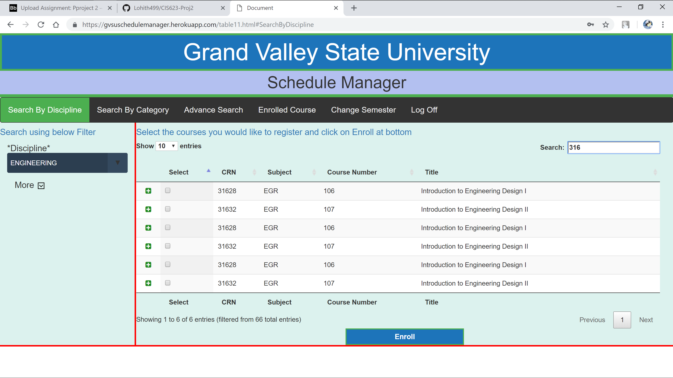

User can select multiple courses at a time for enrollment

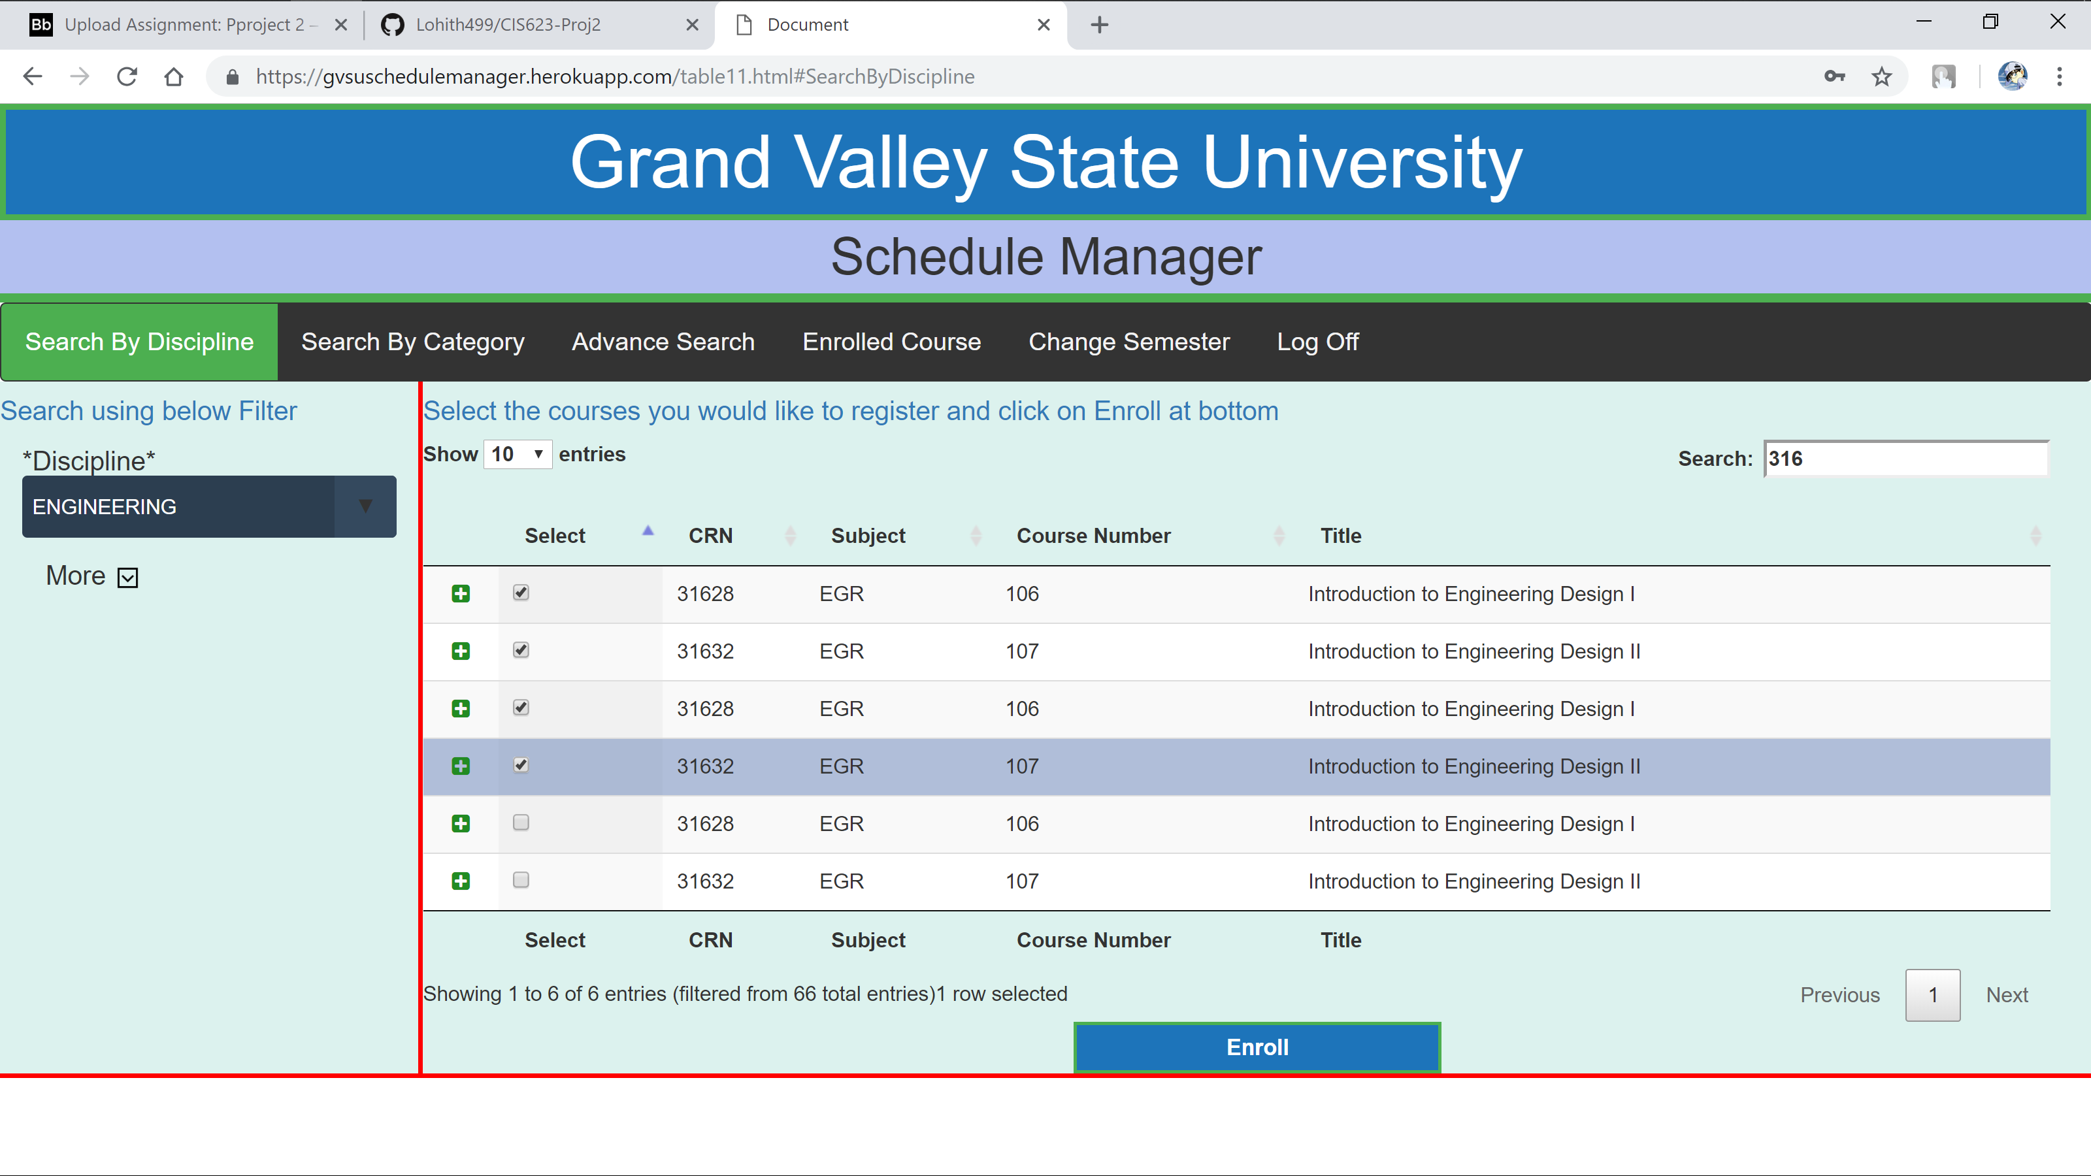

After selecting courses they just need to select and click on Enroll button

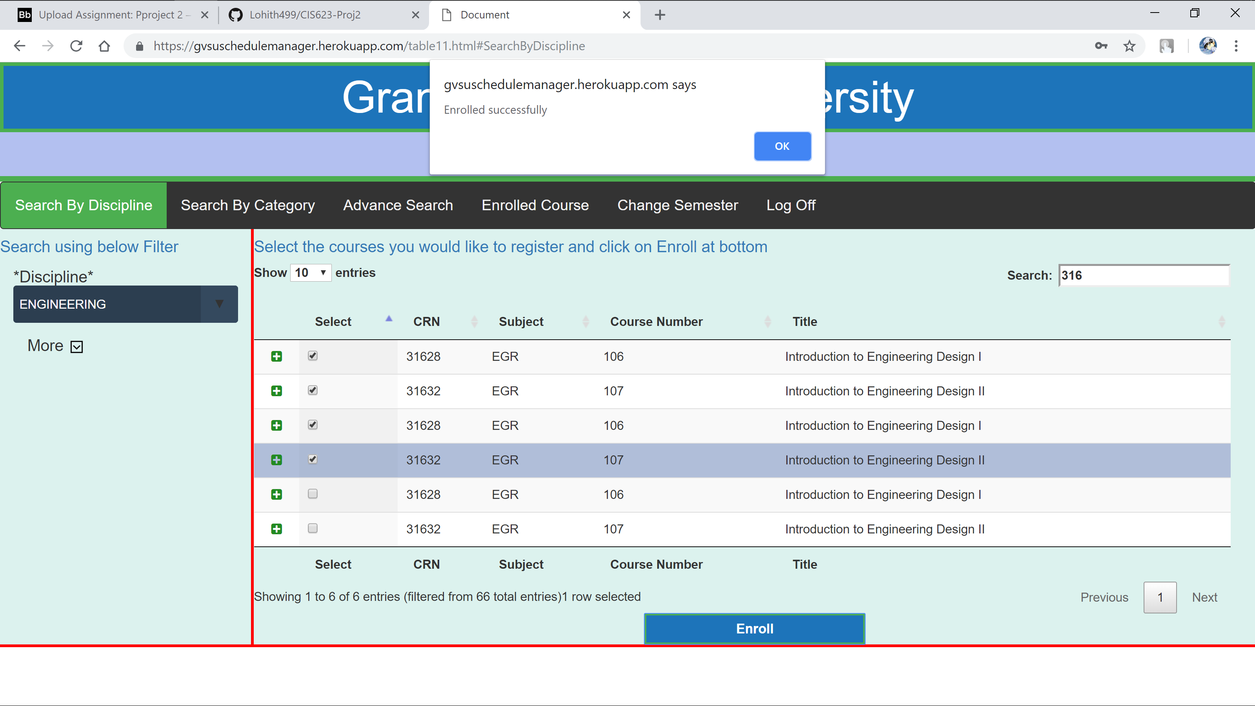

They will be directed to Enrolled Courses tab

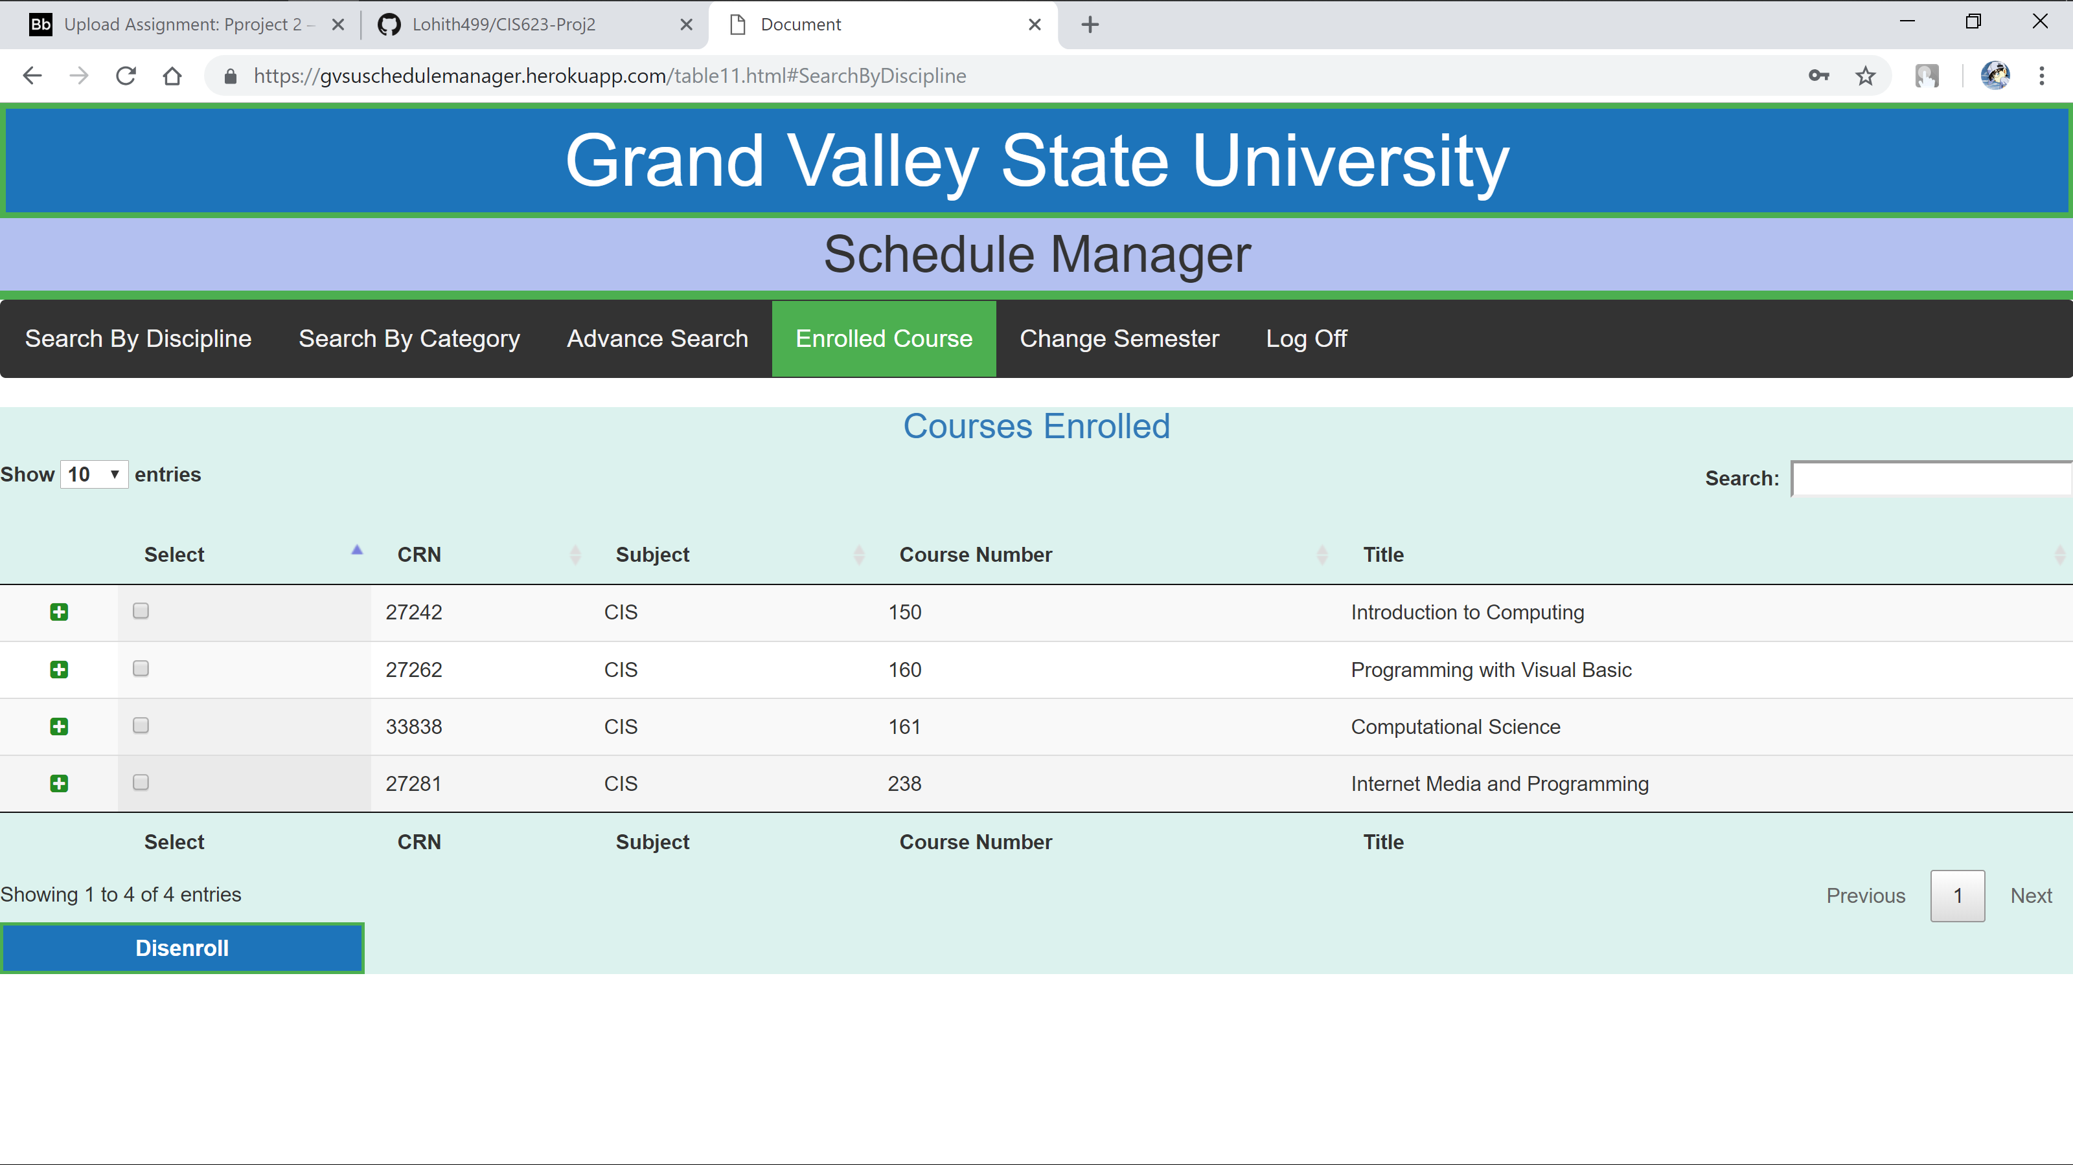Here User can see the courses and if they want to Disenroll they can select multiple course at a time and click on Disenroll

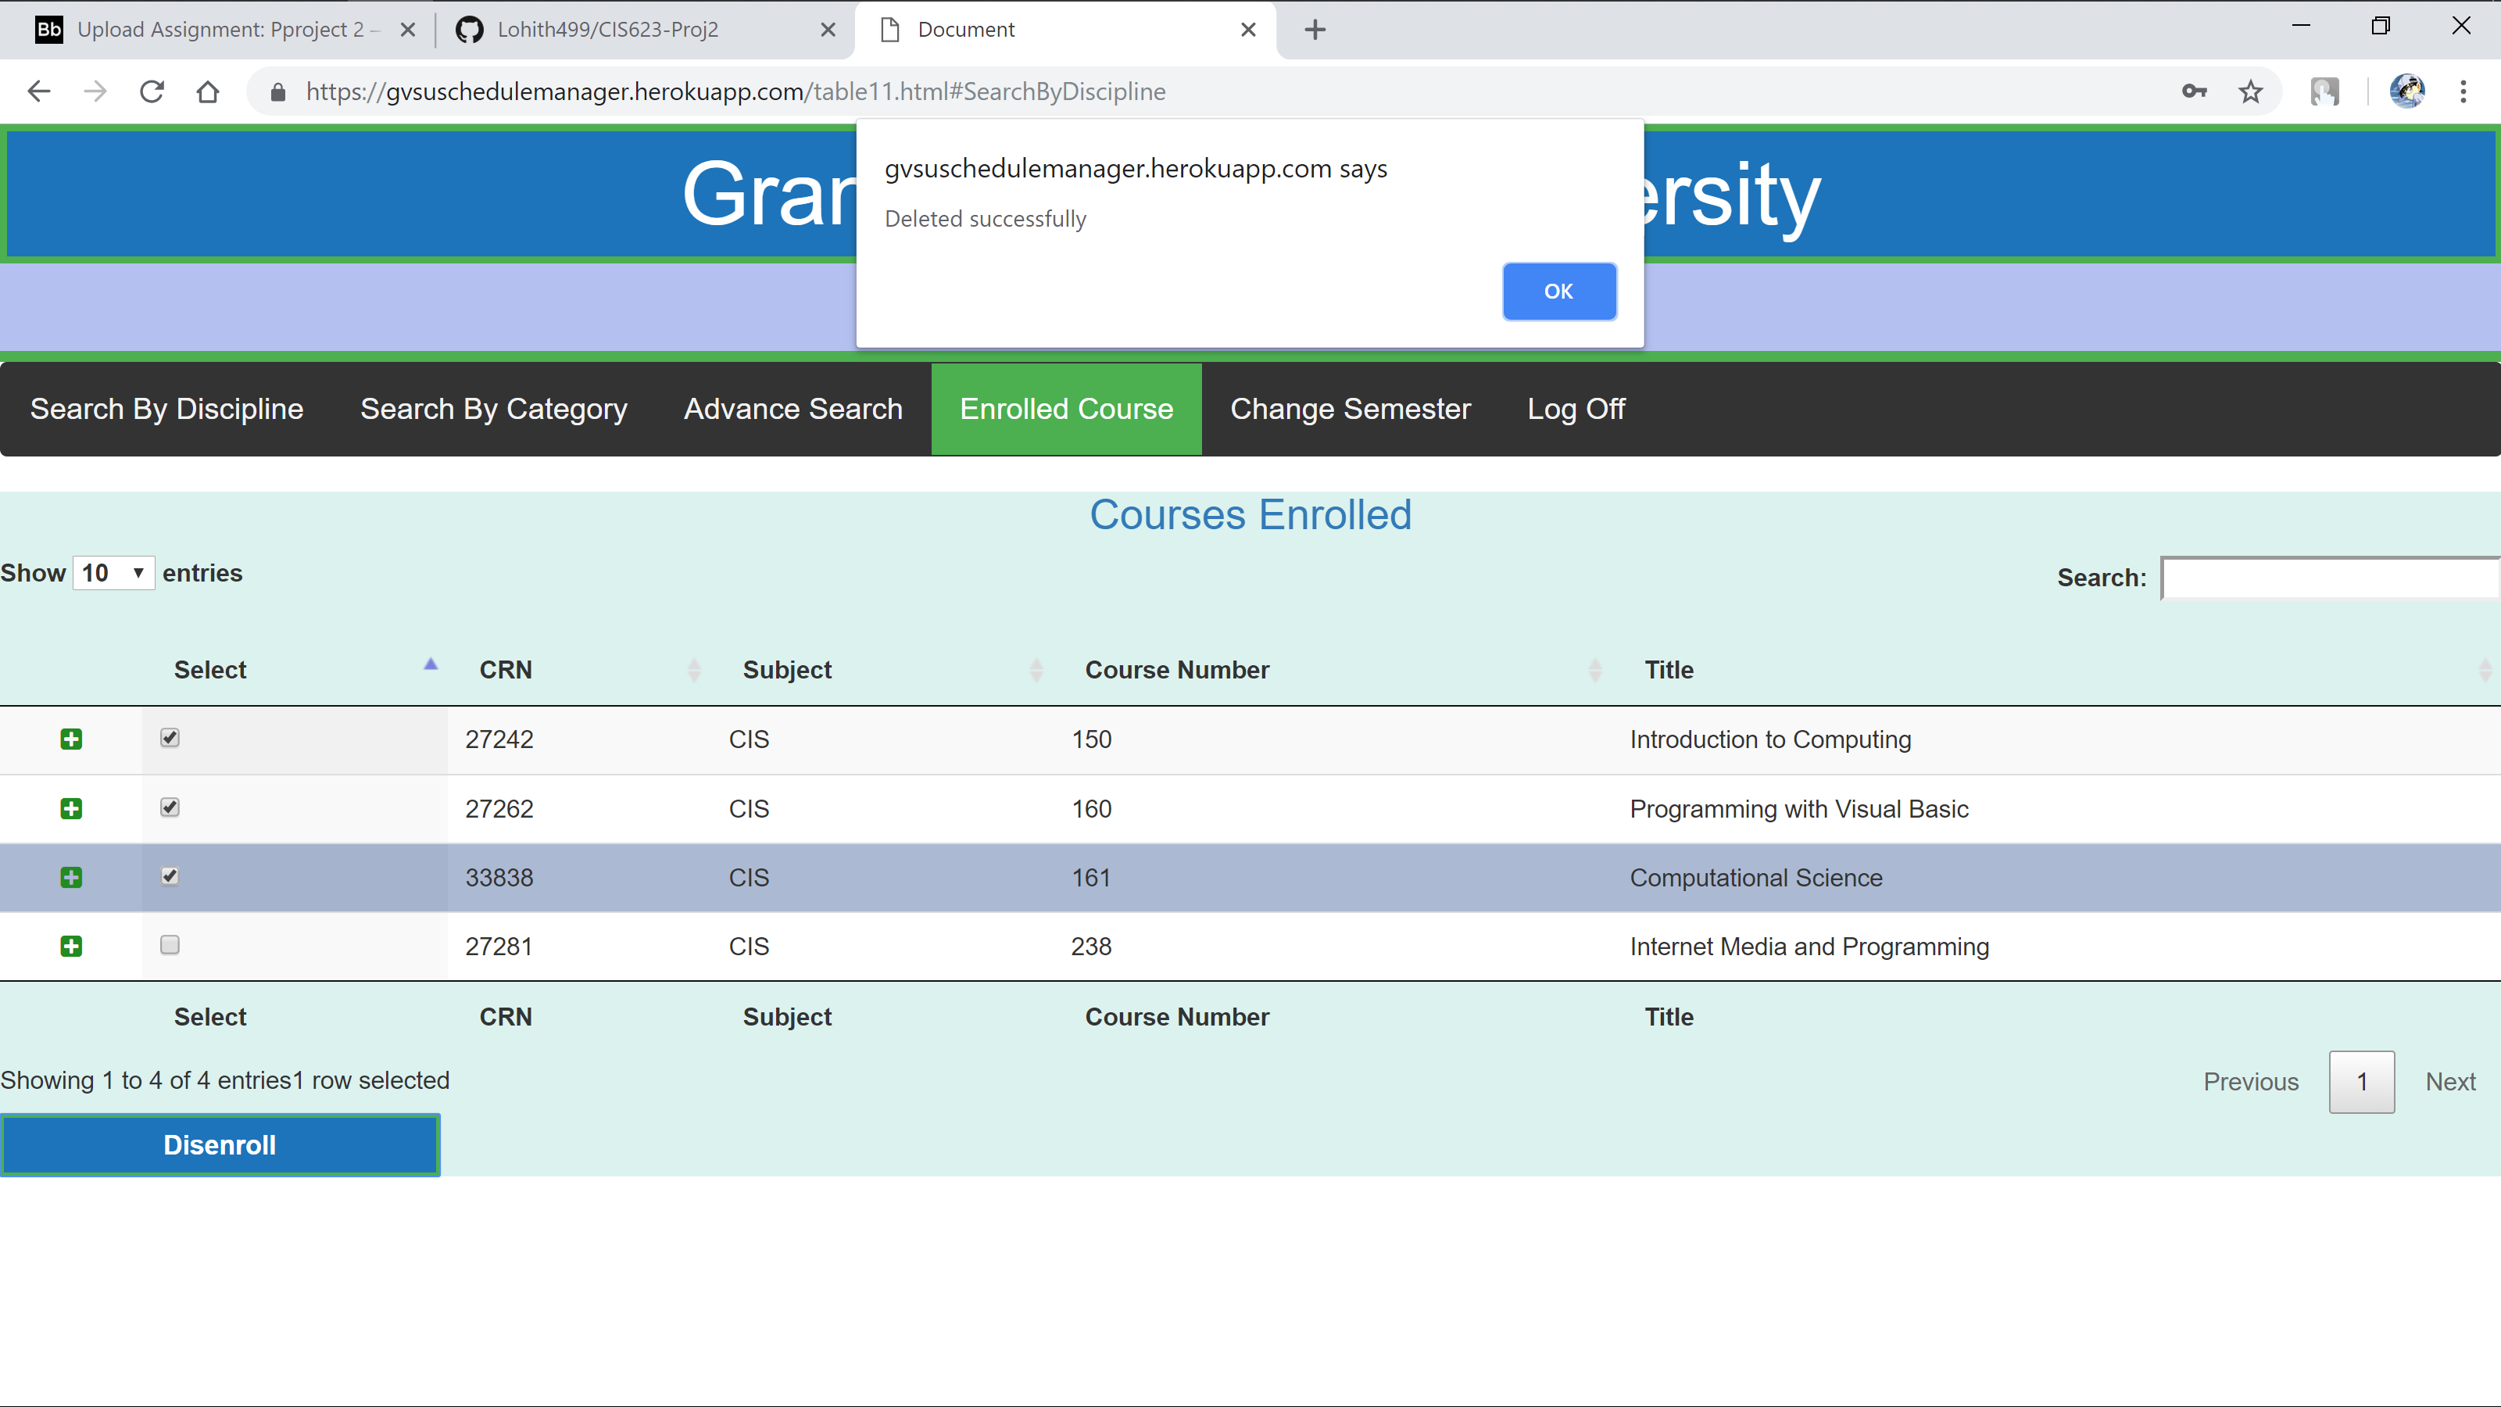

Over here also User can filter using word search and see more details of each course by clicking on **“+”**

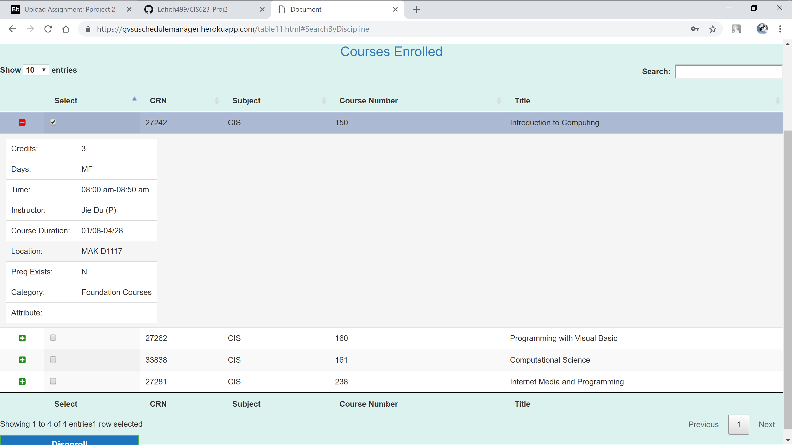

Even this layout is mobile layout compatibility

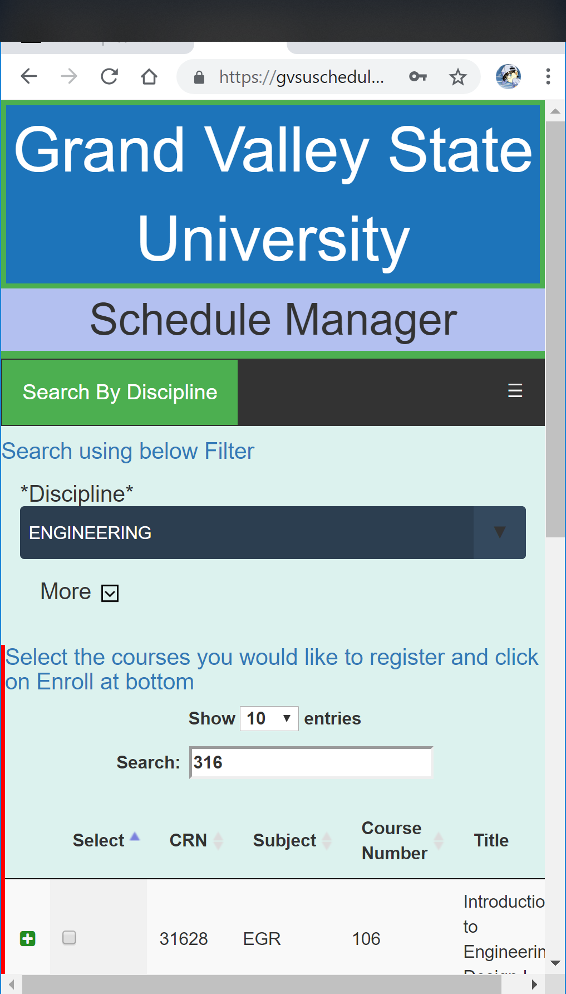 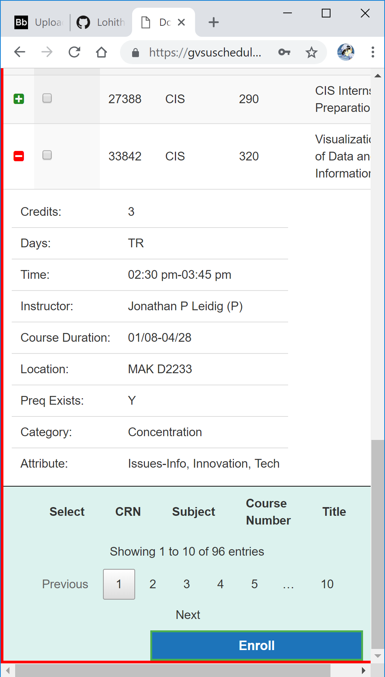

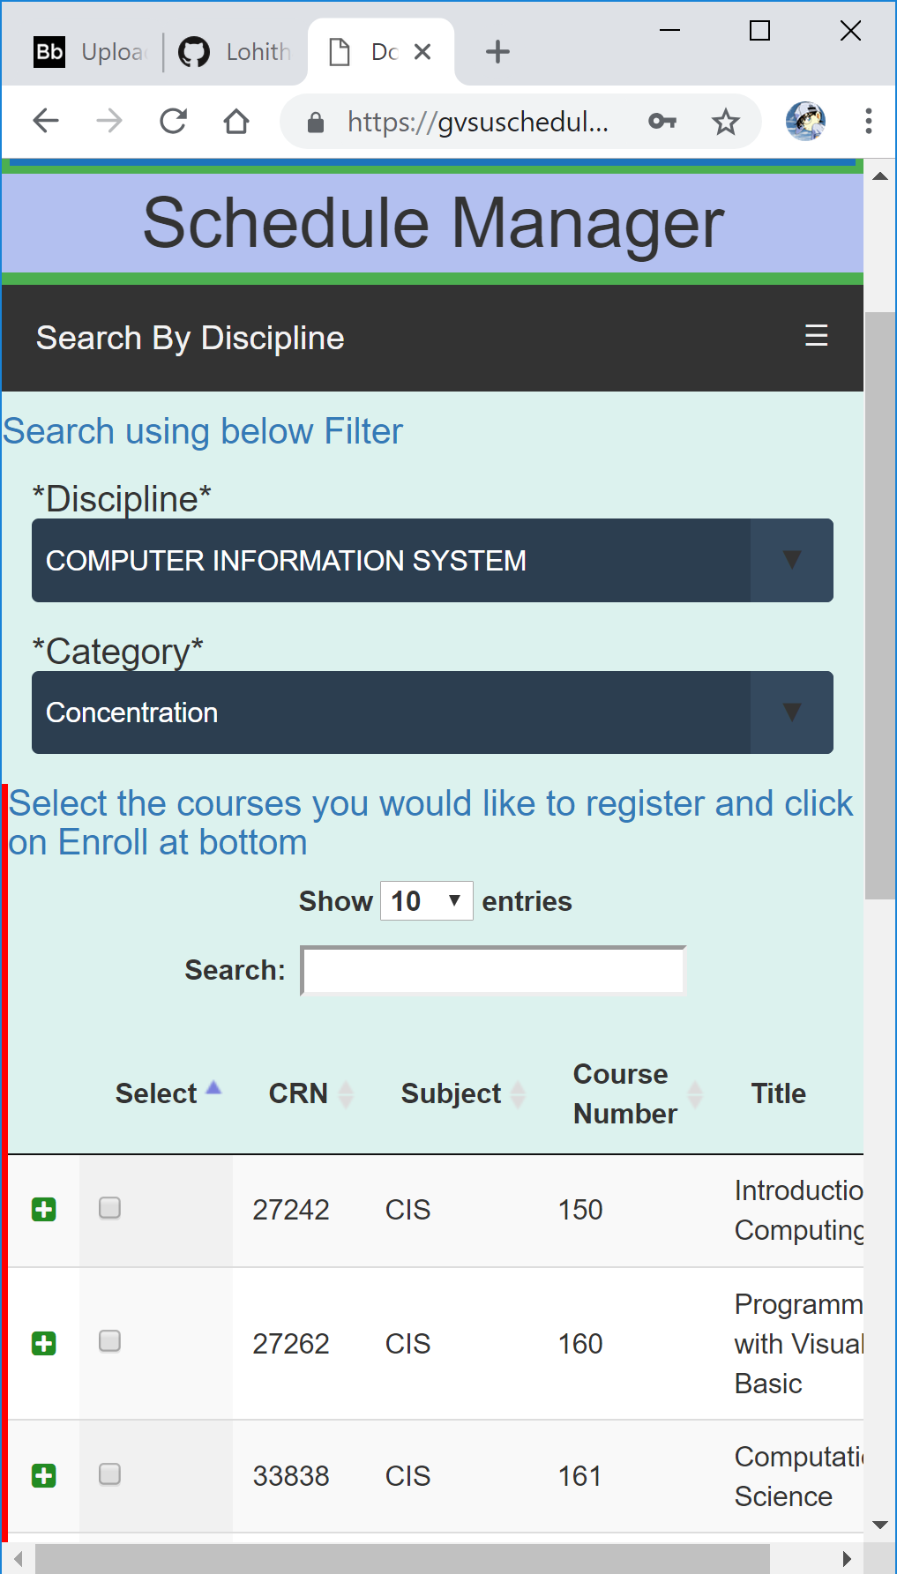 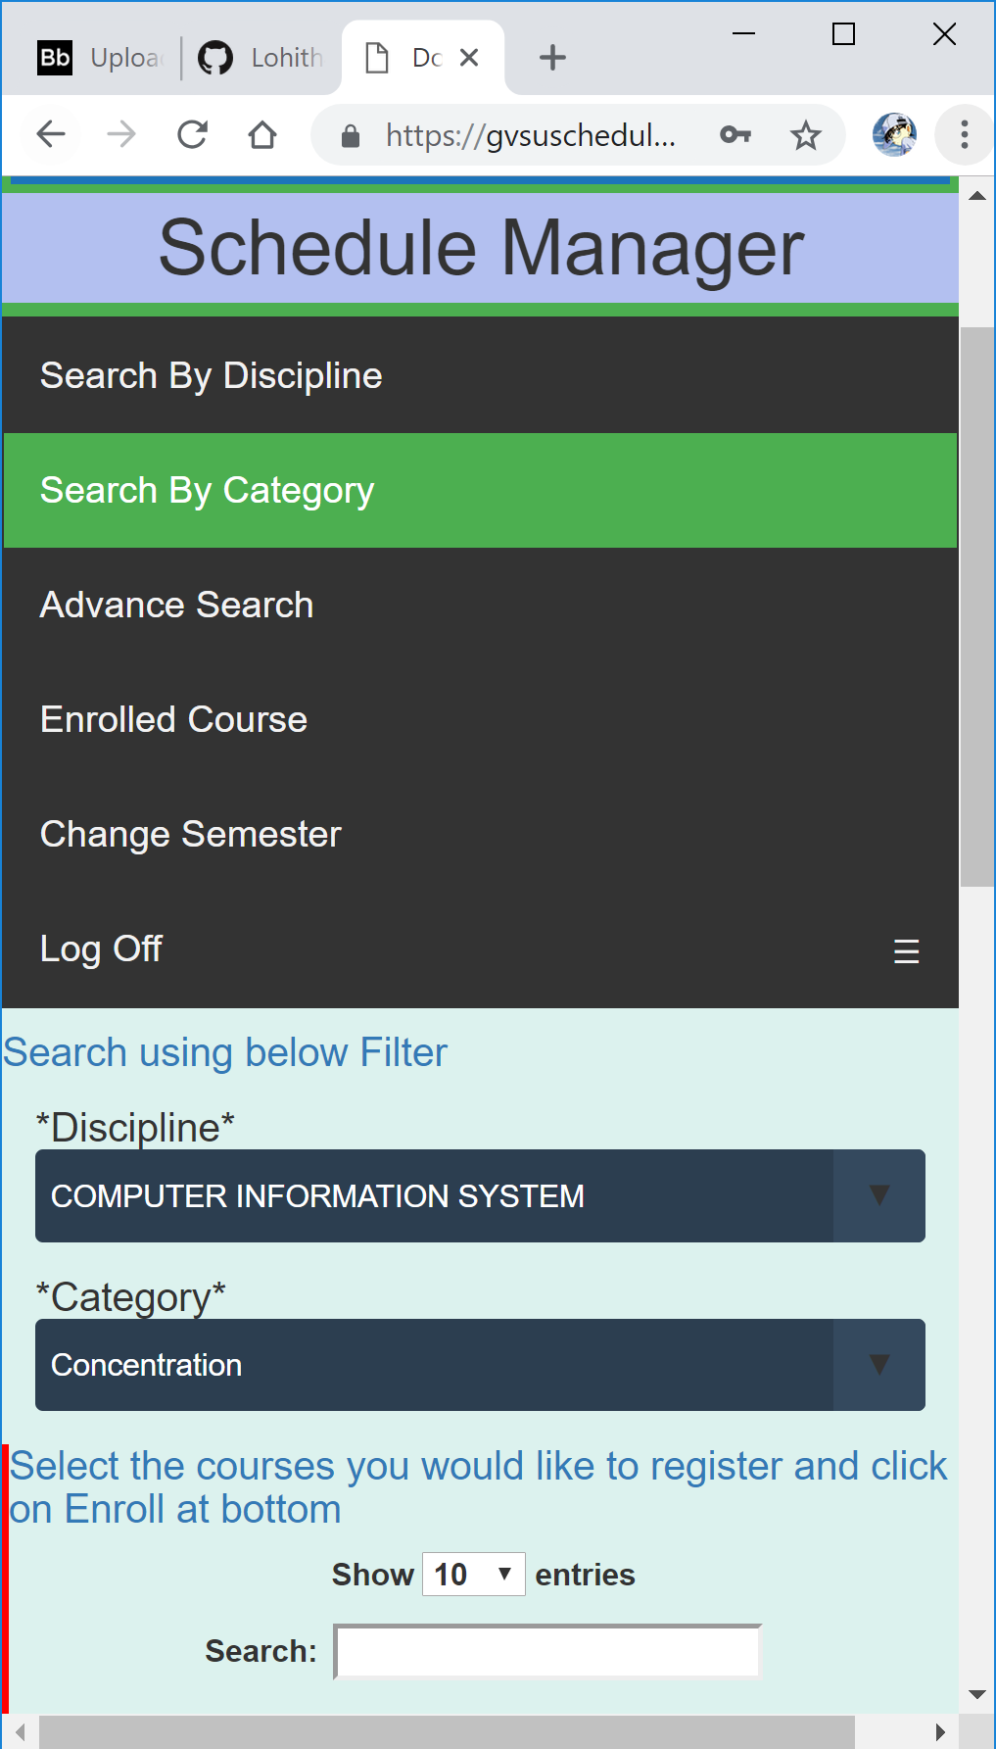

User can change Semester at any time by clicking on Change Semester in the Main Menu

It will route back to default page based on type of user logged in and display to select the semester

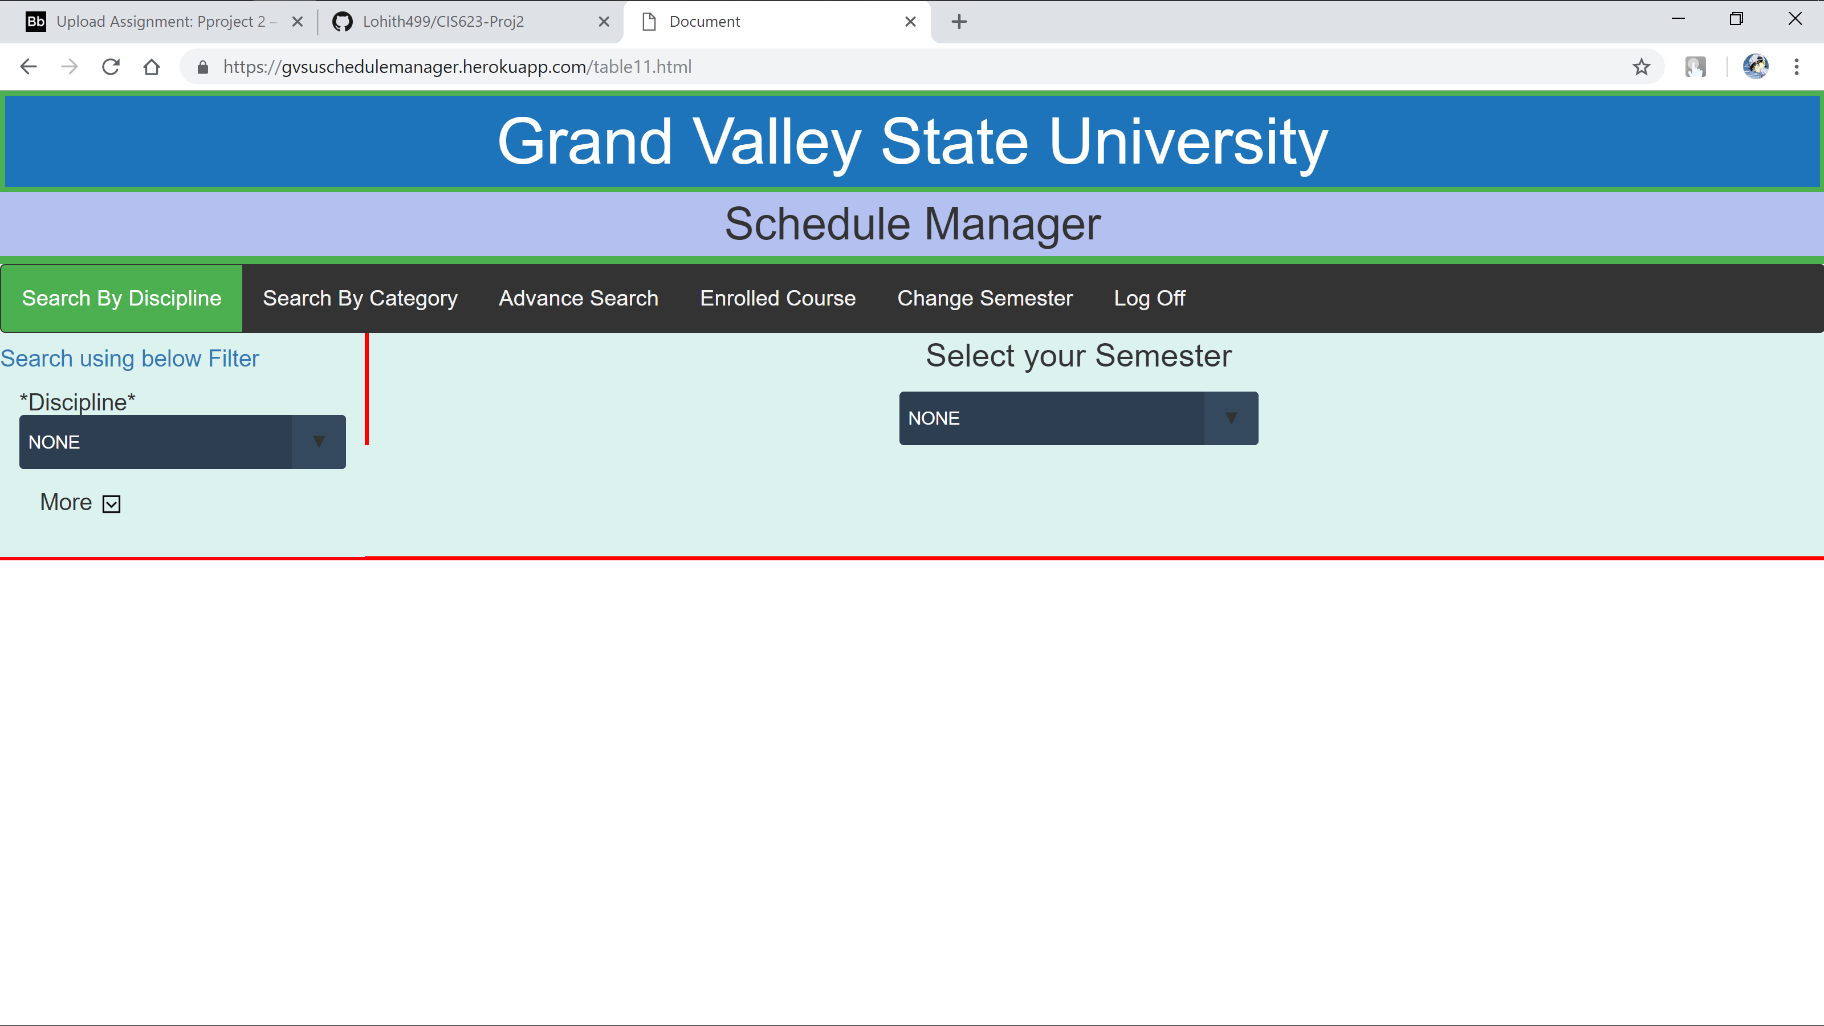

User can Log of by clicking the Log Off button

